DETECTION OF PHISHING WEBSITES USING MACHINE LEARNING

A SEMINAR REPORT

Submitted by

Monish(RA1911003020180)
Yeshwanth(RA1911003020155)
Harish(RA1911003020143)

Under the guidance of
R.Sathya

(Assistant Professor, Department of Computer Science and Engineering)
in partial fulfillment for the award of the degree

BACHELOR OF TECHNOLOGY
IN
COMPUTER SCIENCE AND ENGINEERING
Of
FACULTY OF ENGINEERING AND TECHNOLOGY



SRM INSTITUTE OF SCIENCE AND TECHNOLOGY RAMAPURAM CAMPUS, CHENNAI – 600089

November 2021

SRM INSTITUE OF SCIENCE AND TECHNOLOGY

(Deemed to be University u/S 3 of UGC Act, 1956)

BONAFIDE CERTIFICATE

Certified that this seminar report “DETECTION OF PHISHING WEBSITES USING MACHINE LEARNING” is the bonafide work of “MONISH [RA1911003020180], YESHWANTH [RA1911003020155], HARISH [RA1911003020143]” who carried out the project under my supervision.

SIGNATURE SIGNATURE

Mrs. R. Sathya, MTech (Ph.D) Dr. K. Raja

Assistant Professor Sr.G HEAD OF THE DEPARTMENT
Computer Science and Engineering Computer Science and Engineering
SRM Institute of Science and Technology, SRM Institute of Science and Technology,
Ramapuram Campus, Chennai. Ramapuram Campus, Chennai.

Submitted for the Viva Voce Examination held on ……………….. at SRM Institute of Science and Technology , Ramapuram Campus, Chennai -600089

INTERNAL EXAMINER I INTERNAL EXAMINER II

ABSTRACT
Users on the internet may be vulnerable to various kinds of online threats which have caused lots of financial loss. One of the online threats is phishing. Phishing is a type of cyber-attack sends malicious links or attachments through emails that can perform various functions, including capturing the victim's login credentials or account information. These emails may cause harm to the victims, cause money loss, and identity theft. At first the attacker will send a email to the user which will have a name of some actual vendor, the email will contain a hyperlink which will be similar to that of the legitimate website. The fake website will ask for the user’s personal details, bank account, mobile number, etc. When entered the attacker would have gained access to the information. In this paper we present our solution in solving the phishing attack by developing a mobile application as well as a web extension for the browsers in PC and laptops. They also cause financial problems to companies. So we developing a browser extension as well as an application for mobile phone which will prevent the users from entering a phishing website thus preventing an attack. We do this with the help of both blacklisted database and ML.

iii
TABLE OF CONTENTS

Chapter No. Title Page No.

Abstract iii
List of Tables vi
List of Figures vii
List of Symbols viii

1 Introduction

1.1 Abstract 1
1.2 Problem statement 1
1.3 Scope 2

2 LITERATUTRE SURVEY

2.1 Literature Survey – 1 3
2.2 Literature Survey – 2 3
2.3 Literature Survey – 3 3-4
2.4 Literature Survey – 4 4

3 SYSTEM SPECIFICATIONS

3.1 Introduction 5
3.2 Existing System 5
3.3 Proposed System 5-6
3.4 System Architecture 6

4 MODULE DESCRIPTION

4.1 Feature Extraction 7
4.2 Data Preprocessing 7
4.3 IP Address 7
4.4 URL Length 7
4.5 Suspicious Characters 7
4.6 Suffix & Prefix 7
4.7 Report module 8

5 RESULT AND DISCUSSION 9

6 CONCLUSION 10

7 REFERENCE 11

LIST OF FIGURES
FIGURE 3 – Architecture Diagram of the project 6

vi

LIST OF ABBREVIATIONS

Abbreviations Expansion
ML Machine Learning
URL Uniform Resource Locator
SVM Support vector Machine

vii

CHAPTER 1
INTRODUCTION

1.1 ABSTRACT
Users on the internet may be vulnerable to various kinds of online threats which have caused lots of financial loss. One of the online threats is phishing. Phishing is a type of cyber-attack sends malicious links or attachments through emails that can perform various functions, including capturing the victim's login credentials or account information. These emails may cause harm to the victims, cause money loss, and identity theft. At first the attacker will send a email to the user which will have a name of some actual vendor, the email will contain a hyperlink which will be similar to that of the legitimate website. The fake website will ask for the user’s personal details, bank account, mobile number, etc. When entered the attacker would have gained access to the information. In this paper we present our solution in solving the phishing attack by developing a mobile application as well as a web extension for the browsers in PC and laptops. They also cause financial problems to companies. So we developing a browser extension as well as an application for mobile phone which will prevent the users from entering a phishing website thus preventing an attack. We do this with the help of both blacklisted database and ML.

1.2 PROBLEM STATEMENT
Phishing detection techniques do suffer low detection accuracy and high false alarm especially when novel phishing approaches are introduced. Besides, the most common technique used, blacklist-based method is inefficient in responding to emanating phishing attacks since registering new domain has become easier, no comprehensive blacklist can ensure a perfect up-to-date database.

  - Scope
- Our scope is to safeguard the user from entering the phishing website.
- The dataset obtained from phishtank is used to detect the phishing websites.
- To analyze and detect the phshing websites and prevent the users from entering those websites using Machine Learning.
CHAPTER 2
LITERATURE SURVEY

2.1Vaishnavi Bhavsar, Aditya Kadlak, Shabnam Sharma “Study on Phishing Attacks” on 07-08-2020. In this paper, the author talks about various types of phishing attacks and how they affect the victims. He also talks about the various methods that we can use to detect these types of attacks. The various methods of phishing attacks include web based delivery, email/spam phishing, DNS based phishing, Malware Based phishing, Search engine phishing, Link manipulation and various other types.

2.2 Siddharth Singhal, Utkarsh Chawla, Rajeev Shorey “Machine Learning & Concept Drift based Approach for Malicious Website Detection” on 09-03-2020. The rampant increase in the number of available cyber attack vectors and the frequency of cyber attacks necessitates the implementation of robust cybersecurity systems. Malicious websites are a significant threat to cybersecurity. Miscreants and hackers use malicious websites for illegal activities such as disrupting the functioning of the systems by implanting malware, gaining unauthorized access to systems, or illegally collecting personal information. We propose and implement an approach for classifying malicious and benign websites given their Uniform Resource Locator (URL) as input. Using the URL provided by the user, we collect Lexical, Host-Based, and Content-Based features for the website. These features are fed into a supervised Machine Learning algorithm as input that classifies the URL as malicious or benign. The models are trained on a dataset consisting of multiple malicious and benign URLs. We have evaluated the accuracy of classification for Random forests, Gradient Boosted Decision Trees and Deep Neural Network classifiers. One loophole in the use of Machine learning for detection is the availability of the same training data to the attackers. This data is exploited by the miscreants to alter the features associated with the Malicious URLs, which will be classified as benign by the supervised learning algorithms. Further, owing to the dynamic nature of the malicious websites, we also propose a paradigm for detecting and countering these manually induced concept drifts.

2.3 Paulius Vaitkevičius, Virginijus Marcinkevičius “Comparison of Classification Algorithms for Detection of Phishing Websites” on January 2020. Phishing activities remain a persistent security threat, with global losses exceeding 2.7 billion USD in 2018, according to the FBI’s Internet Crime Complaint Center. In literature, different generations of phishing websites detection methods have been observed. The oldest methods include manual blacklisting of known phishing websites’ URLs in the centralized database, but they have not been able to detect newly launched phishing websites. More recent studies have attempted to solve phishing websites detection as a supervised machine learning problem on phishing datasets, designed on features extracted from phishing websites’ URLs. These studies have shown some classification algorithms performing better than others on differently designed datasets but have not distinguished the best classification algorithm for the phishing websites detection problem in general. The purpose of this research is to compare classic supervised machine learning algorithms on all publicly available phishing datasets with predefined features and to distinguish the best performing algorithm for solving the problem of phishing websites detection, regardless of a specific dataset design. Eight widely used classification algorithms were configured in Python using the Scikit Learn library and tested for classification accuracy on all publicly available phishing datasets. Later, classification algorithms were ranked by accuracy on different datasets using three different ranking techniques while testing the results for a statistically significant difference using Welch’s T-Test. The comparison results are presented in this paper.

2.4 Gourav Karmakar, Saransh Srivastava, Nitish Purohit, Gunjan Budhkar “Detection of Phishing Websites Using Random Forest” on 24-02-2021. The world has moved to automation since the introduction of the Internet. Everything in the world can now be related to internet from banking to E-commerce and military to Social life. At the same time, Internet is the most unsafe place for transmission of data and communication. One can’t guarantee to have a 100% secure link between two End Users. Every second, attackers are finding their way to intrude in governmental as well as private digital premises. The very common attack which is the most popular and can be a successful is phishing. The success of phishing mainly depends on the person’s knowledge about the internet and his/her carelessness about using it. Phishing attack is a way of impersonating some genuine websites using their logos and mottos. They collect user’s login credentials and important detail safter the user gets in trap of this attack. This project traces the very loopholes of internet world and provides a real time application which differentiate between legitimate and phishing websites based on the common features extracted from the websites. This project uses Random Forest to predict the class for the extracted features for a given website.

CHAPTER 3
SYSTEM SPECIFICATIONS
3.1 INTRODUCTION
A System requirements specification (SRS) is a description of a software system to be developed. The software requirements specification lays out functional and non-functional requirements, and it may include a set of use cases that describe user interactions that the software must provide to the user for perfect interaction. Our System will help the users to identify the proven and unproven remedy easily

3.2 EXISTING SYSTEM
There exists many methos to find the phishing websites using various classifiers such as SVM(Support Vector Machine), AdaBoost, Gradient tree boosting, etc. But the random forest method which we have chosen for our system provides slightly higher accuracy percentage than the others. We have also aimed at lower CPU consumption while running in the background to reduce the battery usage which few other systems does not handle well. Making it run as a browser extension means it will consume even less power during the runtime.

3.3 PROPOSED SYSTEM
Our proposed model mainly focuses on identifying the phishing attack based on checking phishing websites features ,the blacklist database and also through our trained model. We are developing a tool as both a browser extension for computers and an application for mobile phones. When a user enters a website our tool will check that website with the blacklisted websites and will prevent the user the website if it is found on the blacklisted database. If the website is not available on the said database it will perform a few analysis based on the training and will act accordingly. According to some research, a few selected features can be used to differentiate between phishing and non-phishing web pages. These selected features include URLs, domain identity, page contents, address bar, mail\mail-to attributes and HTML & JavaScript. These features are checked under several criteria such as IP address, long URL address, and redirecting using symbol “//”. We take several legitimate websites and phishing websites and use it to train our Machine Learning model with these features in mind. We use Random Forest Machine Learning model to train the dataset. Random Forest is used to solve both classification as well as regression problem but for most of the part it is used to solve classification problem. Since the method that we are going to use is classification we are going to be using the Random Forest method. We are going to train the model using different datasets which contains data of both legitimate and phishing websites. The dataset containing legitimate websites are taken from www.dmoz.org and from our personal browsing history. The dataset containing phishing websites are taken from www.phishtank.com.

3.4 ARCHITECTURE DIAGRAM

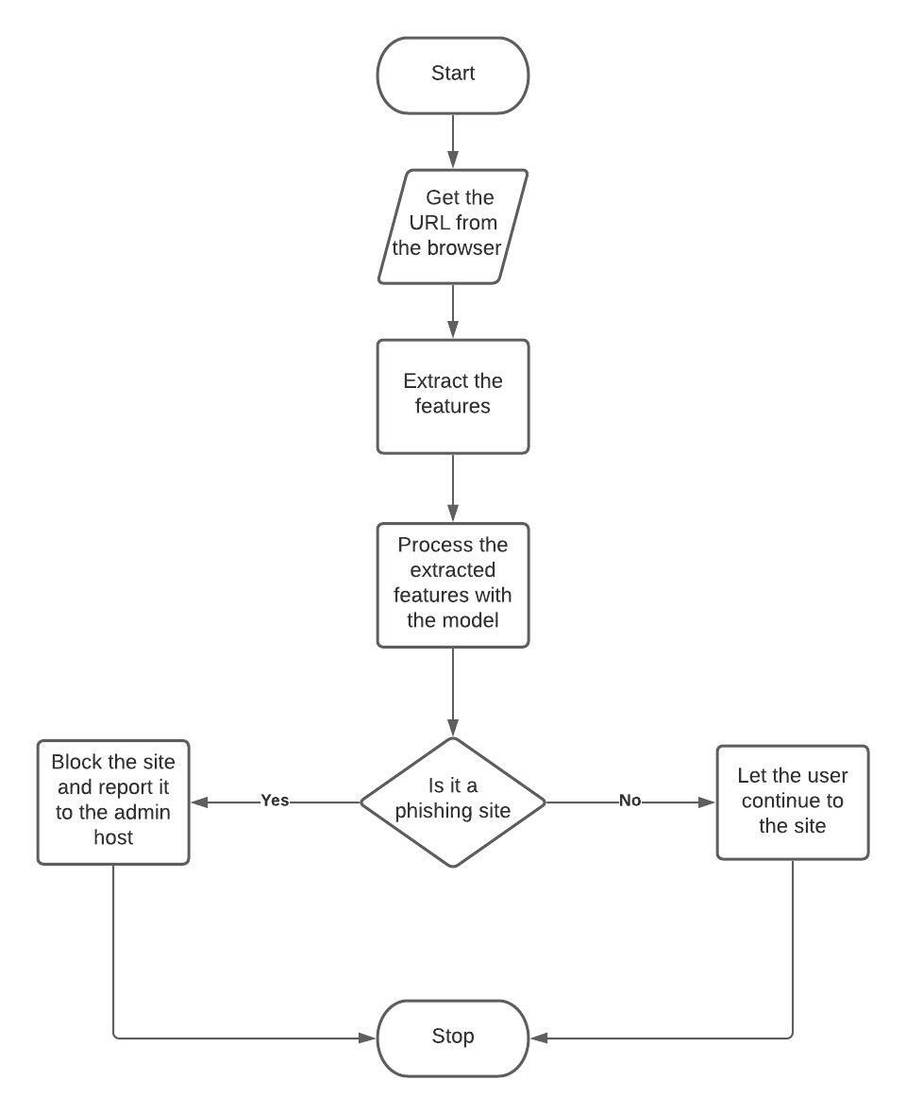
Fig 3: Architecture diagram of the project

CHAPTER 4
MODULE DESCRIPTION

4.1 FEATURE EXTRACTION
The biggest problem of the project is that there are numerous numbers of phishing, trojan and malware website datasets that are published frequently. Phishing websites has no definitive characteristics so it is near impossible to create a dataset which covers every possible characteristics of a phishing website. So we selected a few of the characteristics such as URL, IP address, host, page contents, etc to predict the phishing websites.

4.2 DATA PREPROCESSING
We collected a number of datasets which include legitimate, phishing and malware URLs. This dataset is then analysed for the features such as URL length, special character usage, IP address, HTTPS protocol and decides if the site is legitimate or not.

4.3 IP ADDRESS
If a URL contains an IP address then it is added to the suspected list since no website will have a IP address in them.

4.4 URL RLENGTH
From a survey taken in 2016 a legitimate website contains an average of 20-30 characters if a website has more than that it is suspected to be a phishing (or) malicious website.

4.5 SUSPICIOUS CHARACTERS
Mostly the general browsers will ignore the special characters such as @,$,#, etc but a sequence of these characters means that there is high chance of it being a phishing website.

4.6 SUFFIX & PREFIX
Suffixes and prefixes are not used in a legitimate website so if URL contain any suffix or prefix then most probably it will be phishing website.

4.7 REPORT MODULE: This module will report the detected phishing site to host admin so that they can remove the site.

CHAPTER 5
RESULTS AND DISCUSSION

From the results of the experiments that we have conducted with our system, it shows a very success rate of finding the phishing website at the rate of 93.243%. The dataset that we have used has also been proven very useful for the machine learning algorithm to detect and differentiate a phishing website from a legitimate website. We have chosen random forest algorithm for our system because it is the best way to classify the features in the dataset i.e. URL, IP Address, Suspicious character, etc. Also we didn’t want to try every data mining methods since it would be a really time consuming process to find which one has a high success. It reduces the variance and improves the performance. We are satisfied with our current model with a high success rate but there is still ways to further improve this.

CHAPTER 6
CONCLUSION

We have proposed a browser extension and a mobile application in this paper. The proposed model consists of two algorithms: Database detection and checking the features. We also talked about the effects a phishing attack can have on a user and how it increases year by year. We have hope that we protect those users in the future with our system.

CHAPTER 7
REFERENCE
1. Vaishnavi Bhavsar, Aditya Kadlak, Shabnam Sharma: “Study of phishing attacks” ,2020.
2. Siddharth Singhal, Utkarsh Chawla, Rajeev Shorey: “Machine Learning & Concept Drift based Approach for Malicious Website Detection”, 2020.
3. Paulius Vaitkevičius, Virginijus Marcinkevičius: “Comparison of Classification Algorithms for Detection of Phishing Websites”, 2020.
4. Gourav Karmakar, Saransh Srivastava, Nitish Purohit, Gunjan Budhkar: “Detection of Phishing Websites Using Random Forest”, 2021.
5. Gouse Baig Mohammad, S Shitharth and Puranam Revanth Kumar: “Integrated Machine Learning Model for an URL Phishing Detection”, 2021.
6. Jan Bohacik and Milan Kula: “Webpage phishing detection with data mining”, 2019.
7. Humam Faris and Setiadi Yazid: “Phishing Web Page Detection Methods: URL and HTML Features Detection”, 2021..
8. Smita Sindhu, Sunil Parameshwar Patil, Arya Sreevalsan, Faiz Rahman, Ms. Saritha A. N.: “Phishing Detection using Random Forest, SVM and Neural Network with Backpropagation”, 2020.
9. Shweta Singh, M.P.Singh, Ramprakash Pandey: “Phishing Detection from URLs Using Deep Learning Approach”, 2020.
10. Junaid rashid, Toqeer Mahmood, Muhammad Wasif Nisar and Tahira Nazir:” Phishing detection using machine learning technique”, 2020.
11. DMOZ. Netscape open directory project http://www.dmoz.org.
12. Phishtank Database containing phishing websites - https://phishtank.org/.

